## **Adidas Sales Analysis – Project Summary**

### **Project Objective:**

The primary goal of this analysis is to gain insights into Adidas sales performance across different products, regions, time periods, and retail channels from **January 1, 2020, to December 31, 2021**. This helps stakeholders make data-driven decisions for inventory planning, marketing strategy, and regional expansion.

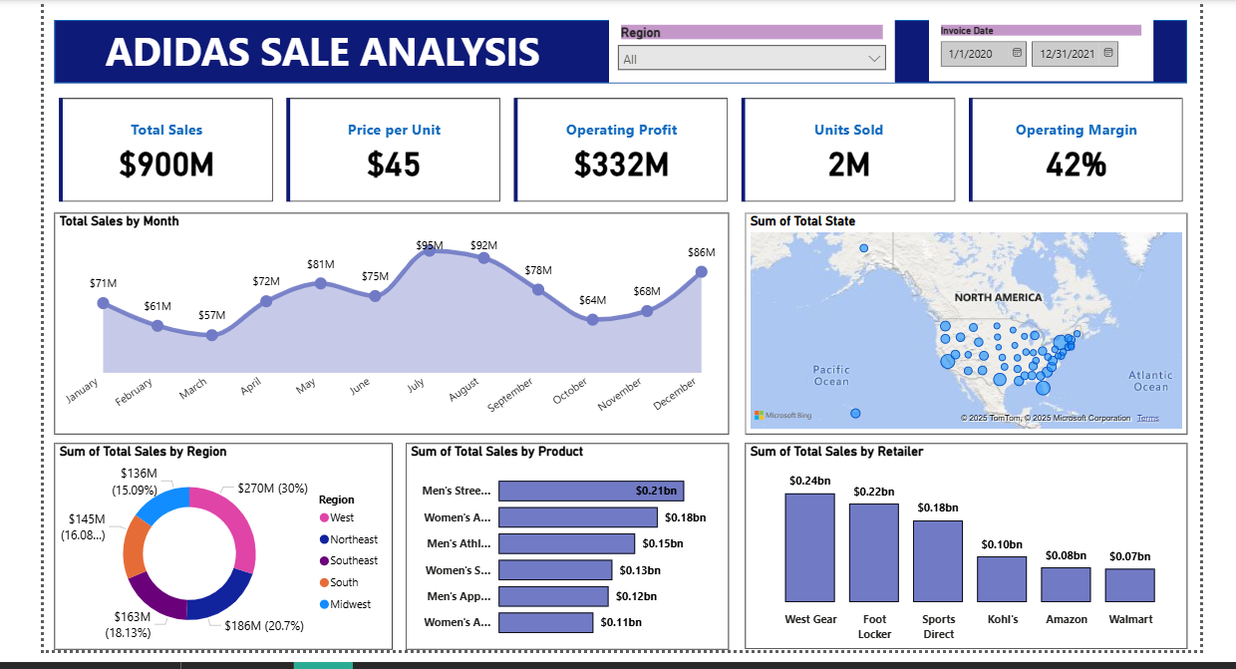

## **Key Metrics Overview:**

| **Metric** | **Value** |
| --- | --- |
| **Total Sales** | **$900M** |
| **Price per Unit** | **$45** |
| **Operating Profit** | **$332M** |
| **Units Sold** | **2 Million** |
| **Operating Margin** | **42%** |

## **Monthly Sales Trend:**

* Sales peaked in **July ($95M)** and **August ($92M)**, likely due to summer promotions or back-to-school campaigns.
* Lowest sales were observed in **March ($57M)** and **February ($61M)**.
* **Q3** showed the highest consistent performance, indicating strong seasonal demand during mid-year.

## **Regional Insights:**

| **Region** | **Sales** | **Contribution** |
| --- | --- | --- |
| **Northeast** | $270M | 30% |
| **Midwest** | $186M | 20.7% |
| **Southeast** | $163M | 18.13% |
| **South** | $145M | 16.08% |
| **West** | $136M | 15.09% |

* **Northeast** is the top-performing region, contributing nearly **one-third** of total sales.
* **West** and **South** underperform comparatively — potential areas for marketing and retail expansion.

## **Product-wise Sales Performance:**

Top-selling categories:

1. **Men’s Streetwear** – $0.21B
2. **Women’s Apparel** – $0.18B
3. **Men’s Athletics** – $0.15B

Less-performing categories include:

* **Women’s Apparel – Sportswear**
* **Men’s Performance Gear**

**Insights:**

* Men’s categories dominate sales, especially **Streetwear** and **Athletics**.
* Women's product categories need better promotion or redesign strategies.

## **Retailer Performance:**

| **Retailer** | **Sales** |
| --- | --- |
| **West Gear** | $0.24B |
| **Foot Locker** | $0.22B |
| **Sports Direct** | $0.18B |
| **Kohl's** | $0.10B |
| **Amazon** | $0.08B |
| **Walmart** | $0.07B |

**Insights:**

* **West Gear** and **Foot Locker** are the primary sales drivers.
* Online channels (e.g., **Amazon**) underperform — opportunity for **digital marketing** and **e-commerce optimization**.

## **Geographic Spread:**

* The sales are spread across various US states, with higher concentration in **Eastern and Central states**.
* Sparse activity observed in **Western states and Alaska**, suggesting under-penetrated markets.

## **Business Insights & Recommendations:**

### **What I Found:**

1. **Strong Q3 sales** highlight seasonal trends.
2. **Northeast region** and **Men’s Streetwear** lead performance.
3. **Amazon and Walmart** underperform despite strong reach.
4. **Price per unit ($45)** aligns with premium positioning.
5. **High Operating Margin (42%)** suggests operational efficiency.

### **Recommendations:**

* **Boost marketing in Q1 and Q4** to flatten the seasonal dip.
* **Expand retail presence and campaigns in West & South regions**.
* **Improve e-commerce sales**, especially via Amazon/Walmart partnerships or exclusive collections.
* **Diversify and promote Women’s segments** to tap into growing demand.
* **Use predictive analytics** to plan inventory and marketing during high-conversion periods.

## **Conclusion:**

This Power BI dashboard provides a comprehensive, real-time overview of Adidas sales data. The insights derived offer strategic opportunities to:

* Maximize profits,
* Enhance regional strategies,
* Improve underperforming segments, and
* Streamline product and retailer-specific initiatives.

This report can be used by marketing, sales, and inventory teams to make **informed, actionable decisions** and drive Adidas' continued growth in the U.S. market.